**Faculty of Computer Science & Information Technology**

**University of Malaya**

**Semester 1, 2016/2017 Academic Session**

**WIX2002: Project Management**

**Tutorial 5**

1. How does earned value give a clearer picture of project schedule and cost status than a simple plan versus actual system?

2. Why is it important for project managers to resist changes to the project baseline?

3. Under what conditions would a project manager make changes to a baseline?

4. In month 9, a project has an earned value of RM2100, an actual cost of RM2000, and a planned cost of RM2400. Compute the SV and CV for the project. What is your assessment of the project?

5. The following data have been collected for a British health care IT project for two-week reporting periods 2 through 12. Compute the SV, CV, SPI, and CPI for each period. Plot the EV and the AC on a summary graph. Plot the SPI, CPI and PCIB on a graph. What is your assessment of the project at the end of period 12?

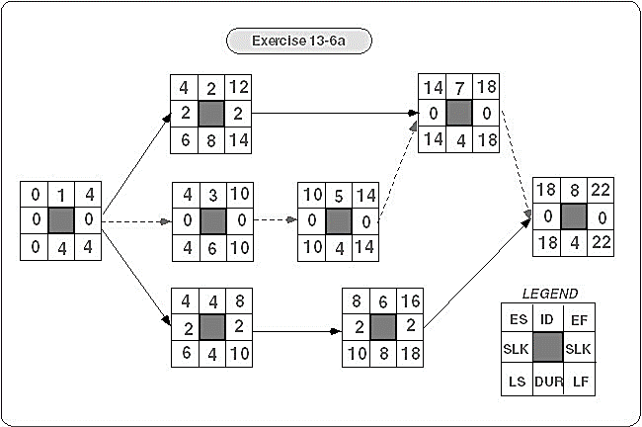

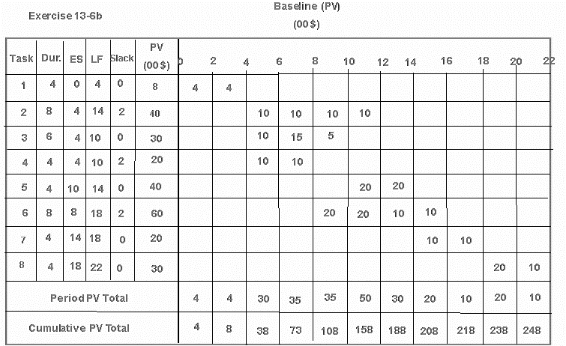

**STATUS REPORT: ENDING PERIOD 2**

|  |  |  |  |  |  |  |
| --- | --- | --- | --- | --- | --- | --- |
| **Task** | **%Complete** | **EV** | **AC** | **PV** | **CV** | **SV** |
| 1 | 50 % |  | 4 |  |  |  |
| **Cumulative Totals** | |  | **4** |  |  |  |

**STATUS REPORT: ENDING PERIOD 4**

|  |  |  |  |  |  |  |
| --- | --- | --- | --- | --- | --- | --- |
| **Task** | **%Complete** | **EV** | **AC** | **PV** | **CV** | **SV** |
| 1 | Finished |  | 10 |  |  |  |
| **Cumulative Totals** | |  | **10** |  |  |  |

**STATUS REPORT: ENDING PERIOD 6**

|  |  |  |  |  |  |  |
| --- | --- | --- | --- | --- | --- | --- |
| **Task** | **%Complete** | **EV** | **AC** | **PV** | **CV** | **SV** |
| 1 | Finished |  | 10 |  |  |  |
| 2 | 25% |  | 15 |  |  |  |
| 3 | 33 % |  | 12 |  |  |  |
| 4 | 0% |  | 0 |  |  |  |
| **Cumulative Totals** | |  | **37** |  |  |  |

**STATUS REPORT: ENDING PERIOD 8**

|  |  |  |  |  |  |  |
| --- | --- | --- | --- | --- | --- | --- |
| **Task** | **%Complete** | **EV** | **AC** | **PV** | **CV** | **SV** |
| 1 | Finished |  | 10 |  |  |  |
| 2 | 30 % |  | 20 |  |  |  |
| 3 | 60 % |  | 25 |  |  |  |
| 4 | 0 % |  | 0 |  |  |  |
| **Cumulative Totals** | |  | **55** |  |  |  |

**STATUS REPORT: ENDING PERIOD 10**

|  |  |  |  |  |  |  |
| --- | --- | --- | --- | --- | --- | --- |
| **Task** | **%Complete** | **EV** | **AC** | **PV** | **CV** | **SV** |
| 1 | Finished |  | 10 |  |  |  |
| 2 | 60 % |  | 30 |  |  |  |
| 3 | Finished |  | 40 |  |  |  |
| 4 | 50 % |  | 20 |  |  |  |
| 5 | 0 % |  | 0 |  |  |  |
| 6 | 30% |  | 24 |  |  |  |
| **Cumulative Totals** | |  | **124** |  |  |  |

**STATUS REPORT: ENDING PERIOD 12**

|  |  |  |  |  |  |  |
| --- | --- | --- | --- | --- | --- | --- |
| **Task** | **%Complete** | **EV** | **AC** | **PV** | **CV** | **SV** |
| 1 | Finished |  | 10 |  |  |  |
| 2 | Finished |  | 50 |  |  |  |
| 3 | Finished |  | 40 |  |  |  |
| 4 | Finished |  | 40 |  |  |  |
| 5 | 50 % |  | 30 |  |  |  |
| 6 | 50% |  | 40 |  |  |  |
| **Cumulative Totals** | |  | **210** |  |  |  |

|  |  |  |  |
| --- | --- | --- | --- |
| **Period** | **SPI** | **CPI** | **PCIB** |
| 2 |  |  |  |
| 4 |  |  |  |
| 6 |  |  |  |
| 8 |  |  |  |
| 10 |  |  |  |
| 12 |  |  |  |

6. How does the project closure review differ from the performance measurement control system?

7. What major information would you expect to find in a project review?

8. Why is it difficult to perform a truly independent, objective review?

9. What is the purpose to include “lessons learned” section in the final project report?

10. What is the purpose of project evaluation? In your opinion, what are the four (4) main aspects that need to be evaluated during team evaluation?